General Tips for Medical Students at East Surrey Hospital

Useful Links (accessible via the intranet on all trust computers)

http://intranet.sash.nhs.uk/department-directory/clinical/acute-medicine/
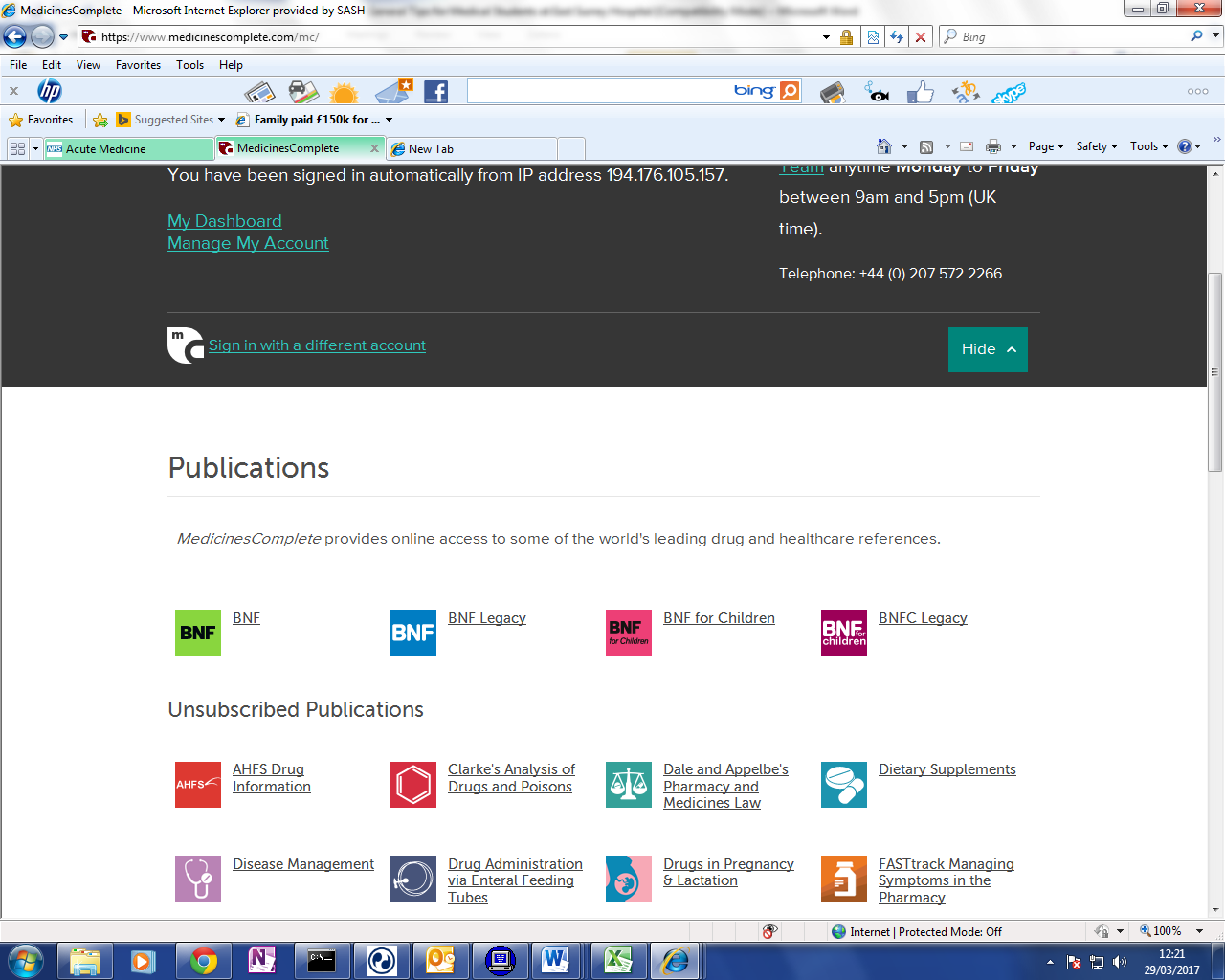
has useful links to eg. E-BNF, trust guidelines (see right hand column)

http://intranet.sash.nhs.uk/department-directory/clinical/acute-medicine/clinicalguidelines
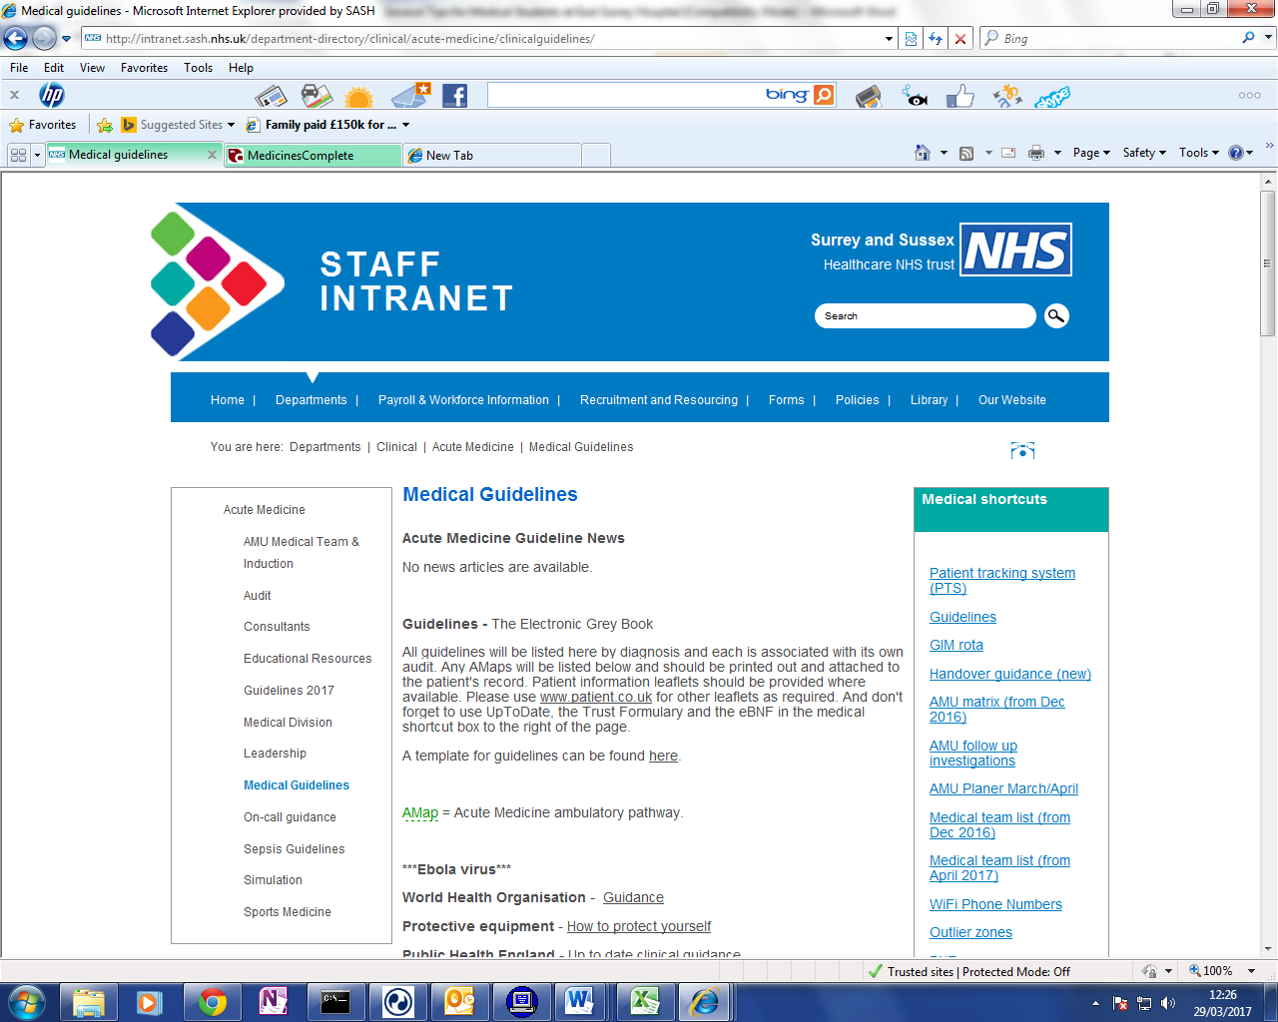
for local trust guidelines for common conditions

http://intranet.sash.nhs.uk/department-directory/clinical/
A wealth of information for ALL inpatient specialties – click each tab on the left

http://www.uptodate.com/contents/search
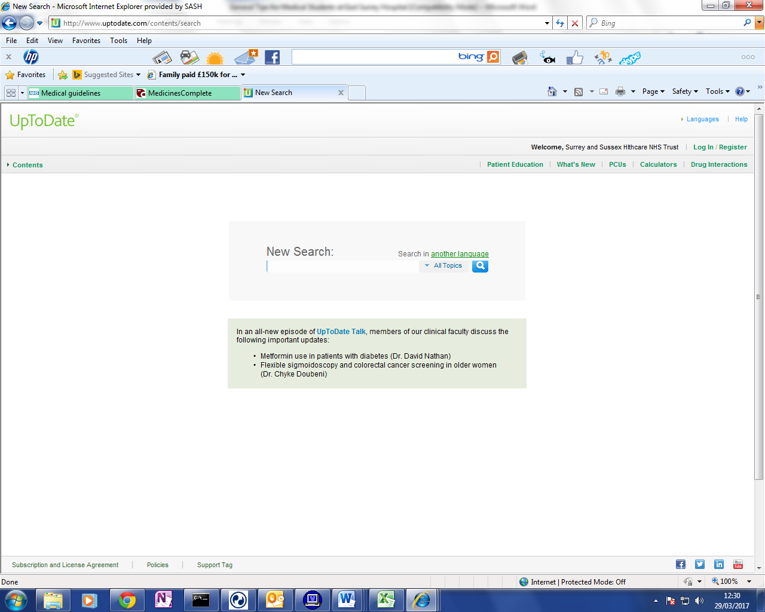
for “uptodate” website with latest national guidance
for almost everything! –
accessible via the favourites tab 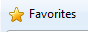 on any trust computer

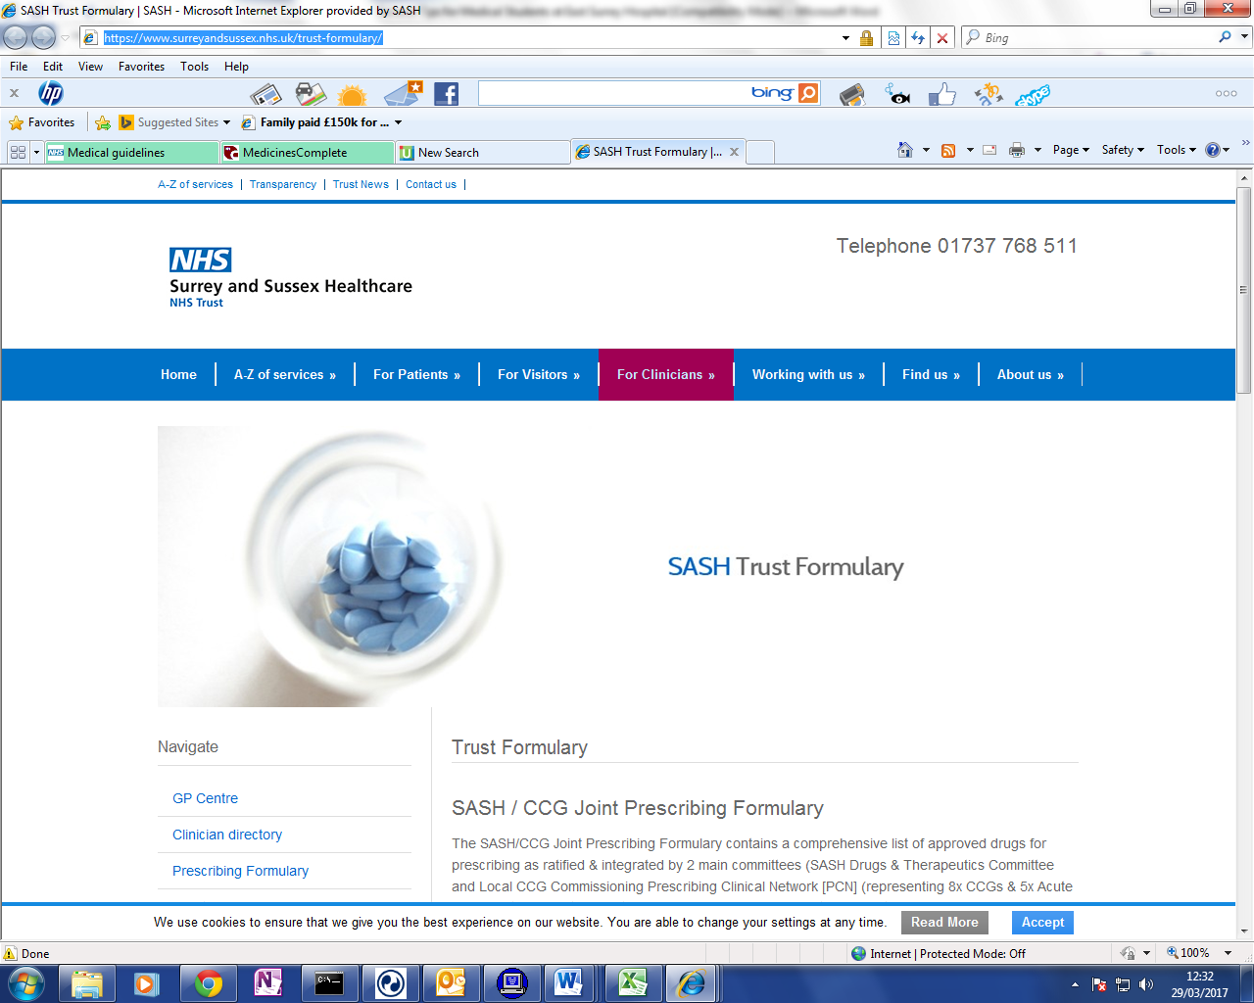
http://www.surreyandsussex.nhs.uk/trust-formulary/
for the trust formulary/drugs

http://microguide.horizonsp.co.uk/viewer/sash/adult
for antibiotic prescribing guidelines
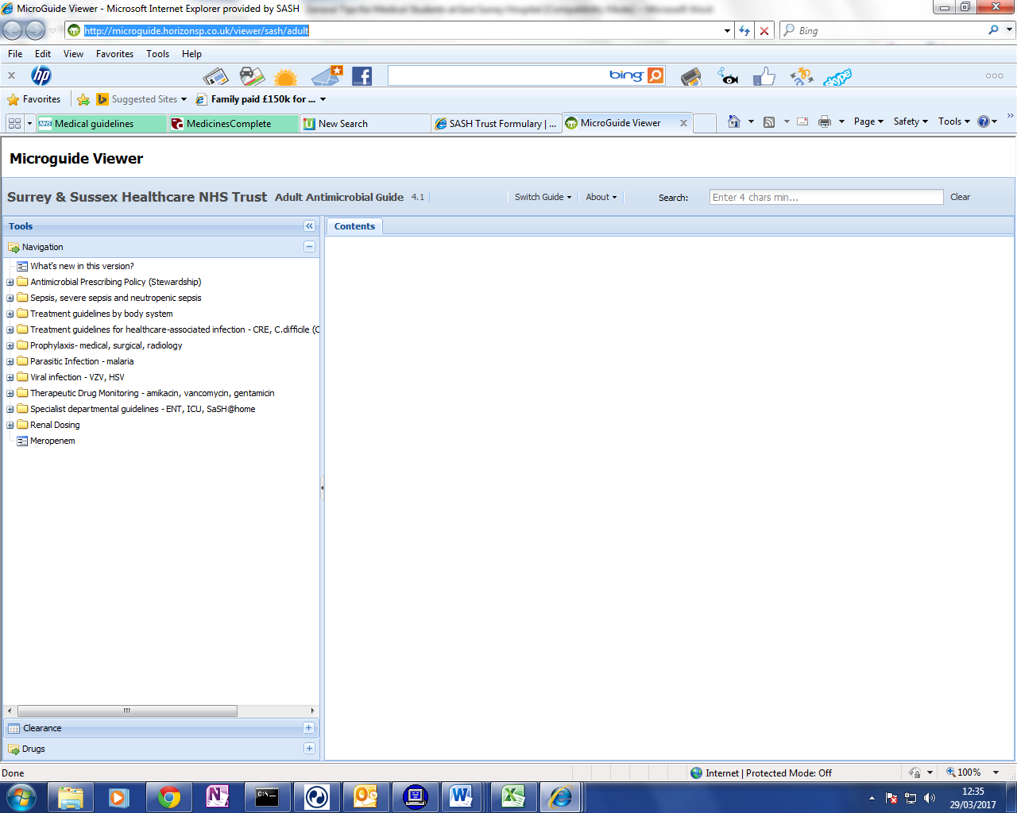
(also accessible via app on smartphones “MicroGuide”
by Horizon Strategic Partners – search for
“Surrey & Sussex Healthcare NHS Trust” for our guidelines)

PTS – Patient Tracking system
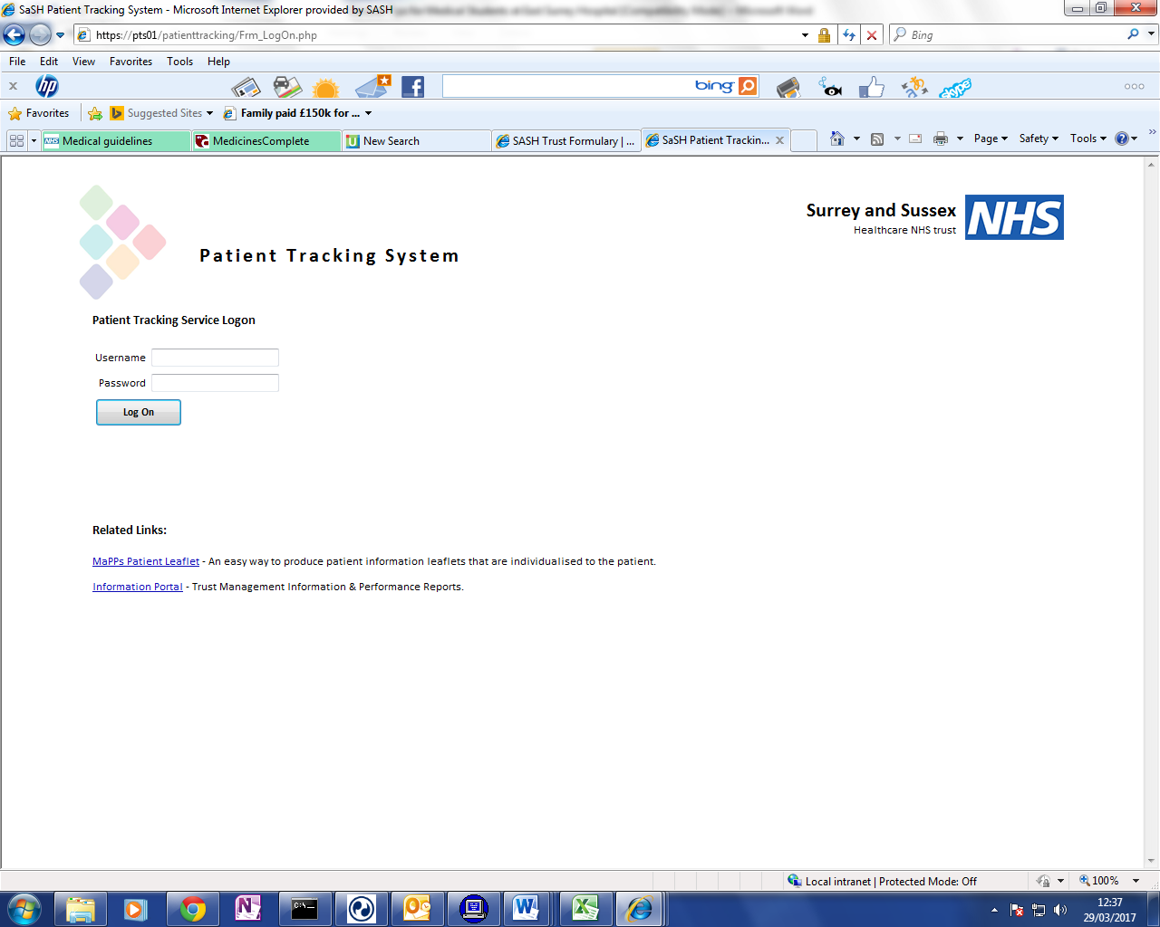
Accessible by typing ‘pts’ into internet search bar.
(username and password then required)
Used for creating Electronic Discharge Summaries
(EDS aka TTO/TTA) and can be used to
look up previous discharge summaries

