GP – Business Mileage
This is a guide to show you how to do a general mileage claim.
Select your vehicle from the drop down list.
Enter the date that the travel incurred on.
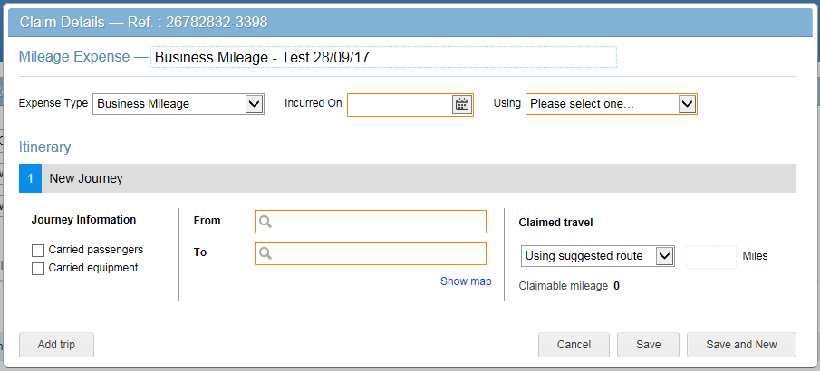
Once you have added the first part of your trip, select “Add Trip” and keep adding further trips until you have returned to base or if you journey bypasses base, to home.
Once you are happy you have done the claim, click ‘Save’ and your expense will be saved (not submitted), and you then need to submit on the next page once you have added all the expenses for that month.
In the ‘To’ box enter the destination you are going to, making sure to have postcode on the address, otherwise it won’t calculate the mileage correctly.
In the ‘From’ box enter where your journey starts from; so from base or home, you need to type “Base” or “Home” depending on where you start. You don’t need to enter home if you are going to base from home first, just start from the base.
Note:
- All mileage is automatically calculated and will minus you usual home to base and back again
- Make sure the mileage is calculated properly, and shows a calculation, remember it will show as 0, if your usual daily home to work travel is less than the journey you have made that day.
Enter a title of your choice.
Make sure to select Business Mileage.

