**NEW STARTERS – ACCESSING PAYSLIPS**

Payslips are online, once you have completed your Staff Appointment Form, and you have been processed on the Payroll system ESR, you will automatically be generated an account.

**DO YOU ALREADY HAVE A NHS SMARTCARD?**

NO  
Please contact the Workforce Information office on: Extensions 1325, 1326 or 1327, to obtain your username and password.

YES  
On the trust Intranet please select **applications** and scroll down to **ESR employee self-service (with smartcard)**

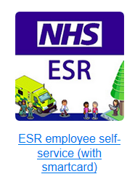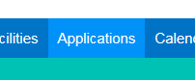

www.sashnet.sash.nhs.uk

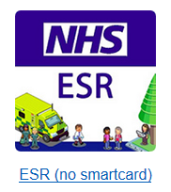

On the trust intranet SASHnet please select applications and go to **ESR (no smartcard)**

Log in with the provided username and password (from the Workforce Information Office), and then you will be prompted to change your password to something new.

www.sashnet.sash.nhs.uk

**ACCESS ON HOME COMPUTER & ON MOBILE PHONE**

Access **Employee Self-Service** with your smartcard on the trust intranet.

Scroll to the bottom of the page and select the option as shown below, **Request Internet Access**

This will present you with a username and ask you to enter password, for use without a smartcard.   
**Please remember your username and chosen password**

You now have access with and without a smartcard and can use this on the mobile app MYESR (available from you app store) or your home computer, via the link below.

**https://myess.esr.nhs.uk**

www.sashnet.sash.nhs.uk

**ACCESS ON HOME COMPUTER & ON MOBILE PHONE**Once you are logged in on the trust intranet, access **Employee Self-Service**  
Scroll to the bottom of the page and select the option as shown below, **Request Internet Access**

You now also have access outside the trust intranet and can use this log in on MYESR app on your mobile (available from your app store) or on your home computer, via the link below.

**https://myess.esr.nhs.uk**



