

INTERNAL MEDICINE TRAINING

EDUCATIONAL PROGRAMME

DEPARTMENT OF MEDICINE AND

CARE OF THE ELDERLY

2019 – 2020

7th August 2019

Welcome to East Surrey Hospital – you are most welcome and we hope very much that you will enjoy your time here. We will do all we can to provide you with a supportive learning environment.

Please take advantage of the IMT education programme and help us to tailor it to your needs. How can you contribute? How can we do better? Please tell us.

Education time is protected and bleep-free. Before attending tutorials and grand rounds, please hand in your bleeps to the Postgraduate Education Centre, unless you are on call.

You will each be given an educational agreement document, to be signed by you and your educational supervisor. We appreciate that patterns of working designed to cope with the European Working Time Directive can make it difficult for you to attend as many educational sessions as you or we would like. However, it is important that you make strenuous efforts to be present when you are in the hospital.

An attendance rate of at least 50% overall (2 hours per week) is expected at the four designated IMT (& CMT) teaching sessions arranged specifically for you (page 3). You are also welcome to attend the many additional educational opportunities available (page 4).

Please attend sessions promptly and sign in. The attendance registers are part of the HEKSS ARCP documentation and are reviewed by the RCP tutor and the Director of Medical Education when considering requests for external study leave. Please would you inform the Postgraduate Education Centre, by email to SASH.PGEC.EastSurrey@nhs.net, when you are unable to attend because of on-call duties or annual / study leave.

Dr Sarah Rafferty Dr Ben Field
Director of Medical Education RCP Tutor

IMT / CMT

WEEKLY EDUCATIONAL PROGRAMME
ALL SESSIONS HELD IN POSTGRADUATE EDUCATION CENTRE

DAY | ORGANISER
MONDAY  12:45-2 pm Cardiorespiratory X-Ray teaching (in X-ray meeting room with lunch)  TUESDAY  1-2 pm IMT / CMT tutorial  WEDNESDAY  1-2 pm Medicine for the Elderly  Journal Club / Case Presentation  THURSDAY  12.30 pm lunch for 1pm prompt start  Grand Round: clinical case presentations  by doctors in training | Dr Ceccherini  CMTs / Dr Field  Dr Prajapati  Clare Leonard / Dr Field

GP TRAINEES ON MEDICAL FIRMS WHO PARTICIPATE
IN THE ACUTE MEDICAL ON CALL ARE STRONGLY ENCOURAGED
TO ATTEND THE ABOVE SESSIONS

CLINICAL TEACHING FOR PACES
Ward based consultant / SpR sessions (meet AMU)
Associate RCP Tutor coordinates the timetable.
Timing of sessions is variable, dependent upon Consultant/SpR availability.

REGIONAL TRAINING DAYS
Run by HEKSS for IMTs & CMTs throughout the year.
Programmes emailed by HEKSS and published on the Synapse website:
https://secure.synapse.nhs.uk/schools-and-organisations/core-medical-training

ROYAL COLLEGE of PHYSICIANS (London & Edinburgh) LECTURES
Watch web-streamed lectures live in the PGEC
Advertised by PGEC
Advance details at www.rcplondon.ac.uk & www.rcpe.ac.uk

IMT / CMT

ADDITIONAL EDUCATIONAL OPPORTUNITIES

Cardiology Ward Round
Weekday mornings on CCU

Intensive Care Multi-Disciplinary Team Meeting
Mondays and Thursdays 11.30am on ITU

Neuroradiology Meeting
Thursdays at 8.45am in PGEC

Gastroenterology Multi-Disciplinary Team Meeting
Tuesdays 8am in PGEC

Generic Professional Training Programme for FY2 Trainees
Tuesdays 12.30pm in PGEC

Medical Audit & Quality Improvement Projects
Presented in Grand Rounds and at departmental Morbidity & Mortality meetings.
All CMTs must complete at least one QIP or audit per year. IMTs – see curriculum.

Haematology Multidisciplinary Team Meeting
Tuesday 3.30pm PGEC
Haematology clinic (please contact Dr O’Donovan to arrange) Tues a.m. Thurs p.m.

Key IMT / CMT contacts:

Director of Medical Education Dr Sarah Rafferty sarahrafferty@nhs.net

Careers Lead Dr Simon Parrington simon.parrington@nhs.net
PG Education Manager Mrs Tina Suttle-Smith tina.suttle-smith@nhs.net
Leadership Lead Mrs Jean Arokiasamy jean.arokiasamy@nhs.net
All the above can be contacted through the PGEC, ext 1722

RCP Tutor Dr Ben Field benjamin.field@nhs.net
Secretary telephone ext 1743

RCP Associate Tutors To be appointed

Dr Sarah Rafferty is the Director of Medical Education and chairs the Trust’s Local Academic Board (LAB) which makes recommendations for our postgraduate junior doctor training.

Dr Ben Field is Royal College of Physicians Tutor for Medicine and oversees the IMT & CMT educational programme. He chairs the Medical Faculty Group (MFG) meetings at which the progress of IMTs & CMTs is reviewed and a report submitted to KSS Deanery, and represents Medicine at LAB meetings. Representatives for each year of IM / CM training are asked to attend the MFG.

Mrs Tina Suttle-Smith is the Strategic Medical Education Manager, in charge of the Postgraduate Education Centre. Tina and her team will be pleased to help IMTs & CMTs with any administrative and training enquiries.

KSS Regional Training Days 2019/20

Details are updated on Synapse. You need to book, via Synapse, because people have sometimes been turned away at the door. Most importantly, you need to let your firm make arrangements for your absence: trigger this by submitting a study leave form.

Date | Hospital | Topic 1 | Topic 2
26 Sep 2018 | St. Richard’s, Chichester | Palliative Care | Gastro / Hepatology
8 Nov 2018 | Maidstone | Cardiology | Oncology
TBA Feb 2019 | Haywards Heath | ID / Public Health | Geriatrics / Stroke
TBA Mar 2019 | Conquest Hospital, Hastings | Acute Medicine | Radiology
13 Mar 2019 | Worthing | Acute Medicine | Radiology
15 May 2019 | Maidstone | Cardiology | Annual Awards (CV time!)
3 Jul 2019 | East Surrey | Endocrinology & Diabetes | Neurology / Psychiatry
18 Jul 2019 | William Harvey, Ashford | Endocrinology & Diabetes | Neurology / Psychiatry
18 Sep 2019 | RSCH, Guildford | Rheumatology | Gastroenterology
16 Oct 2019 | QEQM, Margate | Intensive Care Medicine | Haematology
25 Oct 2019 | St Peter’s, Chertsey | Intensive Care Medicine | Haematology
TBA Dec 2019 | RSCH, Brighton | HIV / GUM | Clin Pharm / Ethics

KSS Regional Training Days and Tuesday lunchtime tutorials aim to cover the Core Medical training competencies outlined in the Specialty Training Curriculum for General Internal Medicine. You are expected to attend so must swap on call shifts (with FY2s and/or GP trainees) if necessary to allow you to do so.

AS A MATTER OF URGENCY, PLEASE SUBMIT STUDY LEAVE APPLICATION FORMS FOR EVERY REGIONAL TRAINING DAY AS SOON AS THE DATES BECOME AVAILABLE.
Core Medical Training and General Internal Medicine

Core Medical Training (CMT) programmes are designed to deliver core training in General Internal Medicine by acquisition of knowledge and skills as assessed by workplace based assessments and the MRCP. Programmes are usually for two years and are broad based consisting of four to six month placements in medical specialties. These placements over the two years must include direct involvement in the acute medical take. Trainees completing CMT will have a solid platform in GIM from which they can continue into Specialty Training. Completion of CMT will be required before entry into specialty training at ST3.

At East Surrey Hospital we have 4 month posts in a selection of the following specialties:

Cardiology Respiratory Medicine
Elderly Medicine Gastroenterology
Endocrinology Acute Medicine
Haematology Rheumatology
Stroke Medicine Dermatology
Intensive Care Medicine Elderly Medicine with Palliative Care

With the exception of ICU and palliative medicine, our posts have a significant general medical component with regular commitment to the acute or general medical take. Core Medical trainees in the Acute Medicine and Haematology posts have a regular commitment to the AMU rota, rather than the general medical rota, for four months. Trainees in ICU participate in the ICU rota. Trainees in Elderly Medicine with Palliative Care Medicine participate in the St Catherine’s Hospice on call rota.

It is up to each trainee to ensure that he/she attends at least 20 clinics per year. As annual leave, study leave and on call shifts keep trainees away from their home wards approximately half the time, you will need to attend an average of two clinics per week.

JRCPTB Specialty Training Curriculum
for General Internal Medicine 2009, amended 2013

This curriculum defines the process of training and the competencies needed for successful completion of Core Medical training. It is trainee-centred and outcome-based. Each trainee must store evidence of attainment of necessary competencies in his or her Royal College of Physicians CMT e-Portfolio (see below). Trainees will be unable to proceed into higher specialist training if there is poor performance in any area.

Royal College of Physicians e-Portfolio

- Record of training
- Declaration of Probity and Health
- Educational Agreements
- Record of Career Discussions
- Self Assessment
- Personal Development Plan
- Reflective Practice (personal development)
- Record of Appraisals
- ARCP documentation
- Record of Competence
- Evidence of Competence
  - Workplace based Assessments
    - Mini-Clinical Evaluation Exercise (mini-CEX)
    - Directly Observed Procedural Skills (DOPS)
    - Multi-source Feedback (MSF)
    - Case based Discussion (CbD)
    - Acute Care Assessment Tool (ACAT)
  - Audit
  - MRCP Performance
  - Certificates of Achievement

Your e-portfolio is a key document and must be kept up-to-date as a record of your training while on the CMT programme. Please note that it is your responsibility to organise and update your e-Portfolio and ensure that all appraisals and assessments are carried out and entered into this document.

Educational Supervision
Each core medicine trainee is allocated a named Educational Supervisor for the year who will conduct appraisals at the start, middle and end of the year. Trainees will also have a Clinical Supervisor for each four month post on their rotation. This is one of the consultants on the firm who is responsible for supervising training within the department.

The role of the Educational Supervisor is to monitor clinical progress and feedback comments on performance to the trainee and subsequently to KSS Deanery via the Medical Faculty Group meetings and the ARCP process. It is vital that Core Medical trainees keep up-to-date with completing their appraisal records for their Royal College of Physicians e-Portfolio.

Appraisal
Appraisal is a planned process concerned with the progress of an individual trainee’s education and development. It should be confidential, non-threatening and a shared ongoing process involving dialogue and agreement between the trainee and his/her educational supervisor. By assisting a trainee to develop the skill of self-appraisal, it should help to identify educational needs as early as possible and allow the trainee to seize opportunities relevant to his/her needs. Appraisals should also provide a mechanism for giving feedback to educational supervisors on the quality of teaching being provided and in this way make education more enjoyable and efficient.

Assessment
Assessment is a process of identifying an individual’s competence, performance, knowledge, skills and attitudes. Educational supervisors should provide doctors in training with a report on their progress. Formal assessment of competence is required for examination purposes and for certain legal requirements, for example the ARCP. For such formal assessment, the purpose is to make explicit and public the competence of an individual.

Audit & Leadership
All trainees must undertake at least one Quality Improvement Project in each year of training. Miss Jean Arokiasamy is Clinical Tutor for Medical Leadership and will be pleased to advise you on suitable projects. Please make contact with her by email: jean.arokiasamy@sash.nhs.uk. All trainees are also expected to complete at least one assessment with a leadership theme on an annual basis. Specific tools are available on the KSS website and must be used.

In Practice
There are two important areas within the e-portfolio that contain blank proformas for educational meeting reports: Appraisal and Progression. Use the forms in the appraisal section for meetings with your Educational Supervisor and Clinical Supervisor throughout the year. You must arrange meetings with your Educational Supervisor within the next week or two, and with each new Clinical Supervisor at the start of each four-month attachment, including your first post, to identify your training needs and hence to discuss your personal development plan. Use the Induction Appraisal form to document these discussions. At the end of each post, your Clinical Supervisor should use the End of Attachment Appraisal form, during a meeting with you, to document your progress and make recommendations about further training.

In addition to meetings with your Clinical Supervisors, you should arrange to meet your Educational Supervisor during each four-month post, to discuss progress and update your e-portfolio assessments, competencies, etc. At the end of each post, you will need to arrange an extra meeting with your Educational Supervisor, to complete the Educational Supervisor’s Report form in the progression section. This report is essential for your ARCP, which is essential for your career progression. It takes ages to complete, there is much discussion and button clicking to be done beforehand, and often it cannot be completed in one session, so make sure you schedule the final meeting several weeks before your ARCP.

It is particularly important that the Educational Supervisor should also receive the trainee’s feedback on the quality of education received during each post, so that where necessary changes can be made for the benefit of subsequent trainees. In this way, appraisal and assessment are a process which aid and improve education locally for the individual and for subsequent colleagues.

ARCP (Annual Review of Competence) Process
This occurs at months 10-11 and 22-23 of core medical training; a satisfactory outcome is essential for career progression. Each trainee will have an interim review with the RCP tutor to discuss the e-portfolio, educational programme attendance and individual supervisors’ reports. Each trainee’s progress is then discussed with all the CMT educational supervisors at the regular Medical Faculty Group meetings, prior to a report being sent to KSS Deanery. The Deanery then reviews your e-portfolio and the Medical Faculty Group report, assessing progress against the CMT ARCP decision aid (see following two pages). An ARCP outcome notification is then issued to the Postgraduate Education Centre. A signed copy is returned to the JRCPTB. Satisfactory ARCP outcomes are your key to progression to higher specialist training.

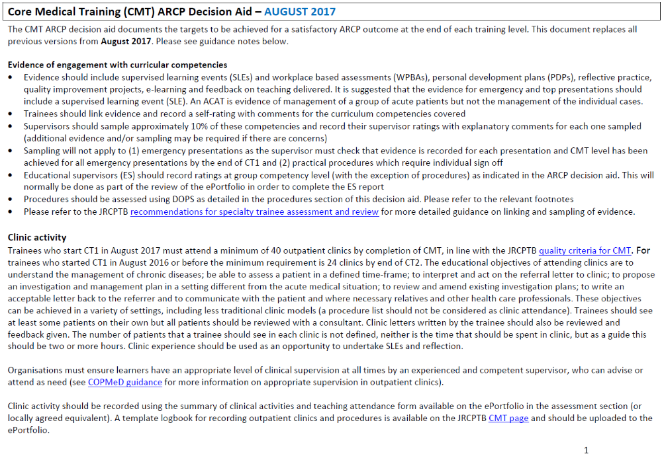

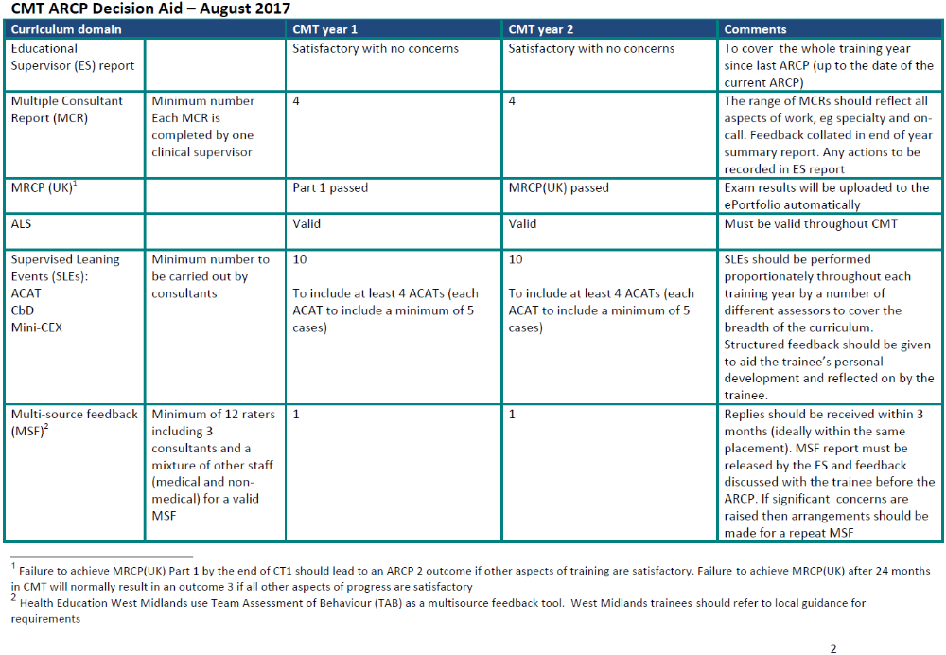

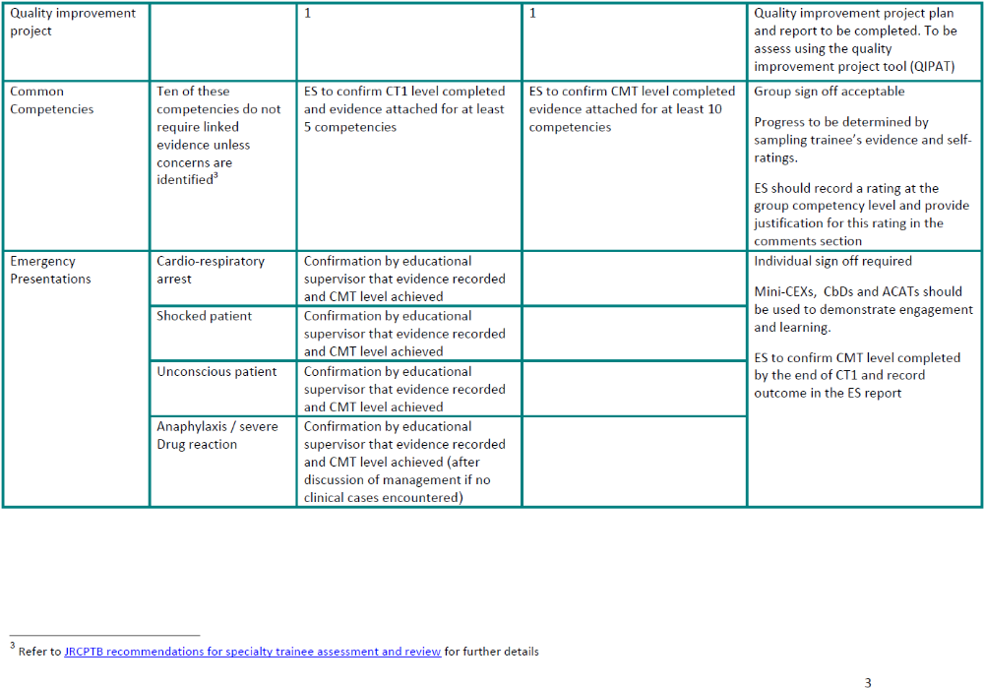

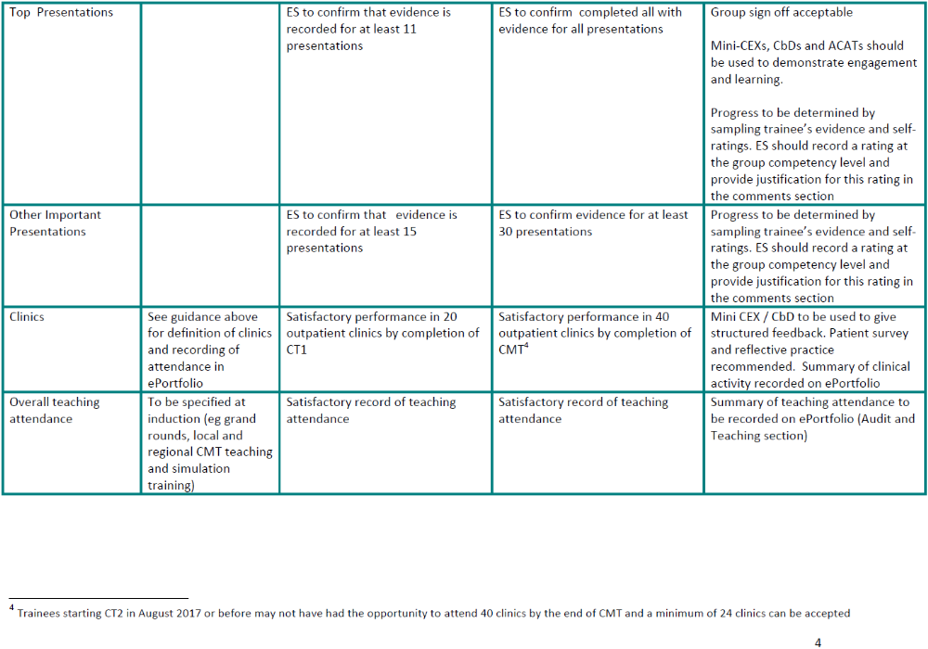

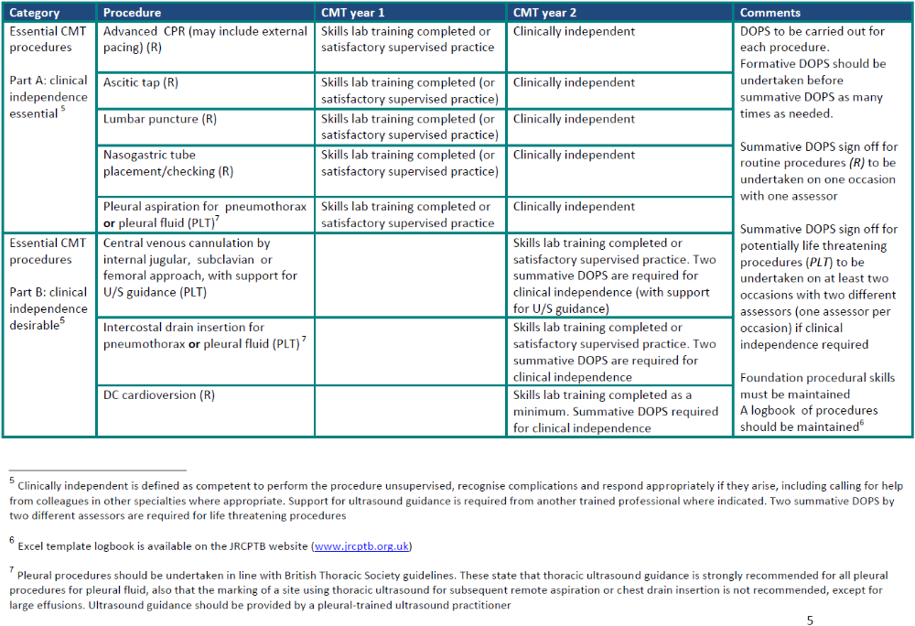

Core Medical Trainee Educational Supervisor and Post Allocations 2018 – 2019
CMT Year | trainee | educational supervisor | Specialty  Aug – Dec 2018 | Specialty  Dec 2018– Apr 2019 | Specialty  Apr – Aug 2019
CMT2 | Rachel Crane | Radha Selvaratnam | Maternity Leave | Maternity leave
CMT2 | Frances Asota | Nayeem Khan | Gastroenterology 60%
CMT2 | Adaeze Nwamarah | Natalie Broomhead | Gastroenterology 60%
CMT2 | Arti Wongcha-um | Deepak Jayaram | Gastroenterology | Respiratory | Dermatology
CMT2 | Alex Byrne | Emma O’Donovan | Stroke Medicine | Haematology | Intensive Care Medicine²
CMT2 | Abirami Pararajasingam | Gary Mackenzie | Intensive Care Medicine² | Dermatology | Stroke Medicine
CMT2 | Alessandro Antonello | Jonathan Nolan | Respiratory | Intensive Care Medicine² | Geriatric & Palliative Medicine³
CMT2 | Bibeg Gurung | Laura Ferrigan | Endocrinology & diabetes | Cardiology | Acute Medicine¹
CMT2 | Boris Tocco | James Clark | Intensive Care Medicine² | Acute Medicine¹ | Rheumatology
CMT2 | Carys Fleming | Iain Wilkinson | Haematology | Endocrinology & diabetes | Cardiology
CMT2 | Chinmayi Chandrashekar | Devi Acharya | Acute Medicine¹ 60% | Rheumatology 60% | Respiratory 60%
CMT2 | Jamie Thoroughgood | Padmini Sastry | Cardiology | Geriatric & Palliative Medicine³ | Endocrinology & diabetes
CMT2 | Luizee Buchan | Monira Rahman | Dermatology | Gastroenterology | Haematology
CMT1 | Alana Rochester | Muhammad Jawad | Intensive Care Medicine² | Respiratory | Geriatric medicine
CMT1 | Alexander Presland | Martin Dachsel | Geriatric medicine | Acute Medicine¹ | Gastroenterology
CMT1 | Chloe Angwin | Cheuk Chan | Intensive Care Medicine² | Geriatric Medicine & Community⁴ | Cardiology
CMT1 | Demi Wright | Borja Moya | Acute Medicine¹ | Intensive Care Medicine² | Geriatric Medicine & Community⁴
CMT1 | Giada Azzopardi | Juliana Barla | Respiratory | Cardiology | Acute Medicine¹
CMT1 | James Heyes | James Sneddon | Cardiology | Acute Medicine¹ | Rheumatology
CMT1 | Kugananda Sriparanthaman | Sian Griffith | Geriatric Medicine & Community⁴ | Rheumatology | Gastroenterology
CMT1 | Libin Mathew | Andres Acosta | Acute Medicine¹ | Geriatric Medicine & Community⁴ | Intensive Care Medicine²
CMT1 | Mili Dhar | Gayatri Chakrabarty | Endocrinology & diabetes | Gastroenterology | Geriatric Medicine & Community⁴
CMT1 | Natalie Clayden | Barry Jackson | Geriatric Medicine & Community⁴ | Intensive Care Medicine² | Endocrinology & diabetes
CMT1 | Radhika Patel | Ursula Davies | Rheumatology | Geriatric medicine | Respiratory medicine
CMT1 | Sophie Norman | Vidhu Nayyar | Rheumatology | Endocrinology & diabetes | Intensive Care Medicine²
NB: [1] CMTs on AMU and haematology contribute to the AMU rota, not the General Medical on-call rota, and therefore have no night on-call commitment.
[2] CMTs on intensive care medicine contribute to the ICU rota.
[3] CMTs on geriatric medicine with palliative care contribute to the St Catherine’s Hospice rota only, for the entire four-month post, including while based at ESH.
[4] “Geriatric Medicine & Community” indicates post in geriatric medicine with community geriatric medicine experience.

