EASY System

Self-Registration
You will need to self-register to use EASY Expense system. This gives you access to the Self-Service area of the EASY system. How this works is that you submit your work email address to EASY, and if this is recognised by the system you will receive an email that contains a token (computer jargon for a special code) or a link to a page in EASY.

To Self-Registration
To start the Self-Registration process, click on the Register here link at the bottom right of the EASY Login screen (see below).
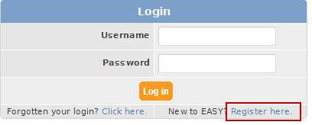
This takes you to the User Registration page where you enter your work’s email address or Employee number (see example below).
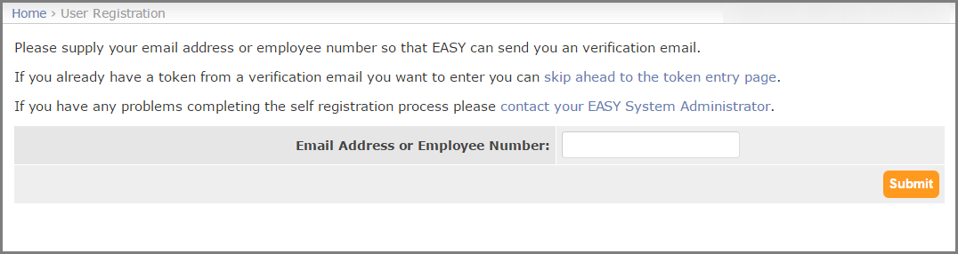
When you click on the Submit button.
Firstly, an email message similar to the one below will be sent to you.

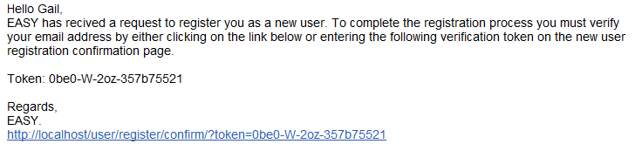
Secondly, the User Confirm Registration page (see below) is displayed.
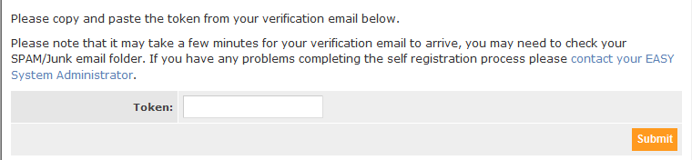
You will need to copy the Token from the email and paste it into the Token Field.
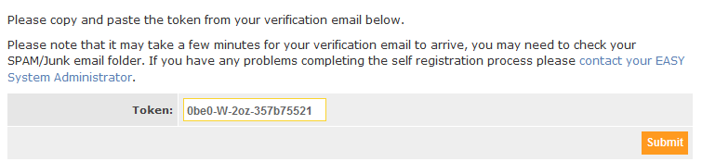
When you click on the Submit button
You will now need to Create a Password page (see below) is displayed.
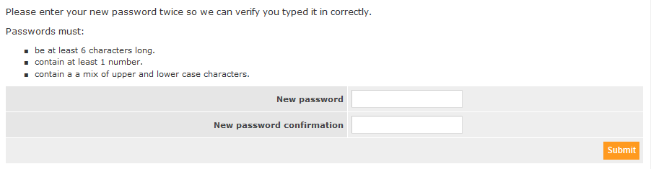
Enter a password
- be a least 6 characters in length
- contain at least 1 number
- Contain a mixture of upper and lower-case characters.
click on the Submit button
You will be presented with the Create Security Word page.
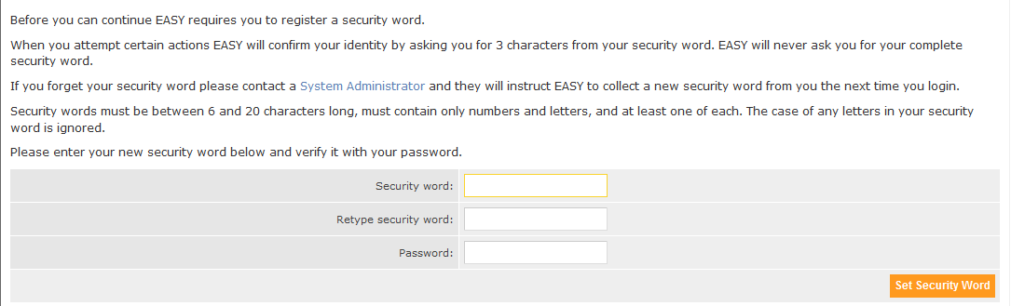
The EASY system asks you at different stages for 3 characters from your Security Word, this acts as your electronic signature. The security word must contain and be easy to remember.
- must be between 6 and 20 characters in length
- must contain both letters and numbers

As a confirmation you need to enter your password (this is the new password that you entered earlier).
When you click on the Set Security Word button or press the Enter key, you will be presented with the EASY Expense login page

